EMPLOYEE ATTENDANCE ANALYSIS USING EXCEL & PYTHON

OBJECTIVE:
The objective of this project is to analyze employee attendance data and identify attendance patterns, department performance, and employee participation trends.
TOOLS USED:
• Microsoft Excel – Data cleaning
• Python (Pandas) – Data analysis
• Matplotlib – Visualization
DATASET DESCRIPTION:
The dataset contains employee attendance records including employee names, departments, and attendance percentages. The data was cleaned and analyzed to identify attendance trends and department-wise performance.

PROGRAM:
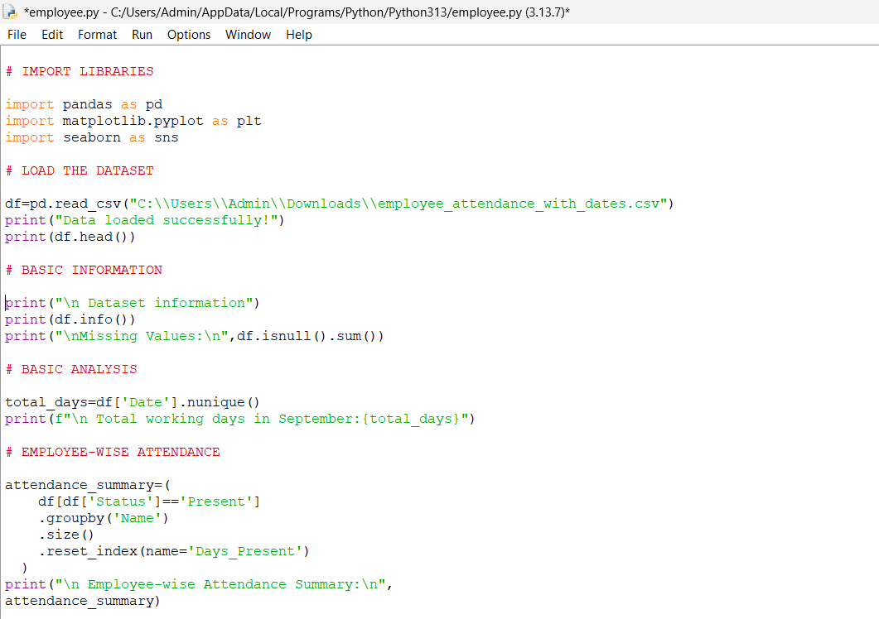
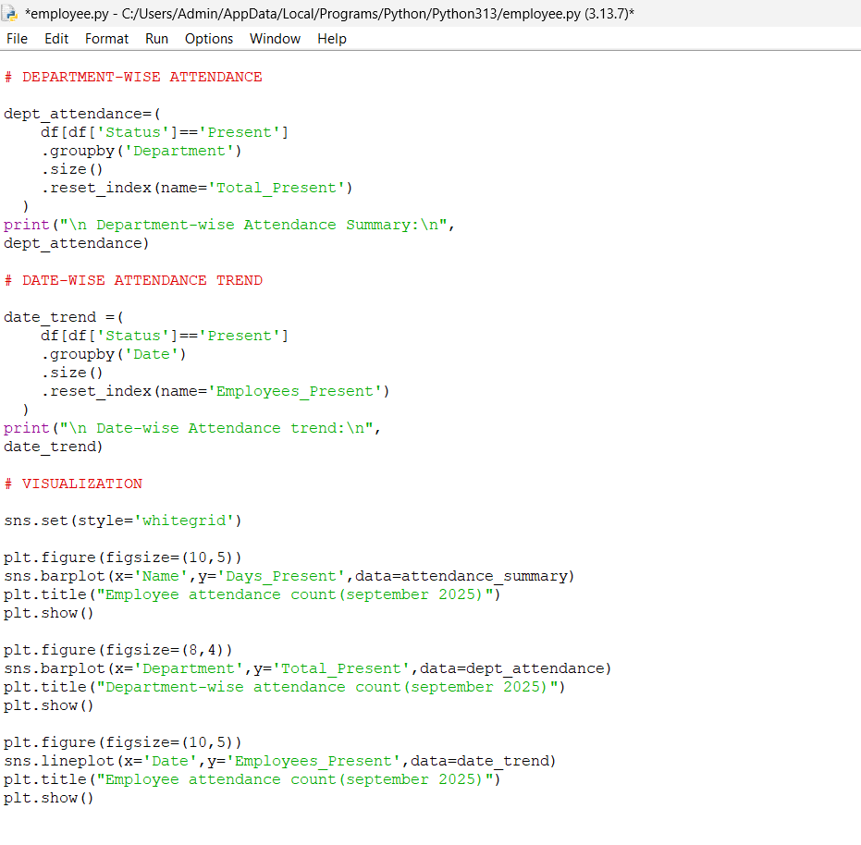OUTPUT:
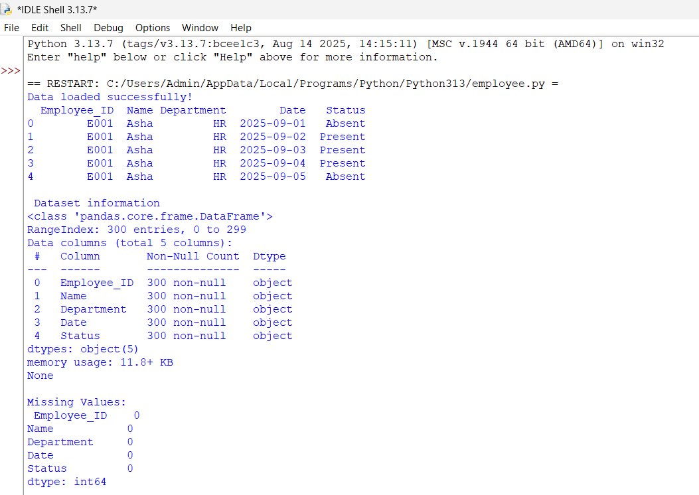
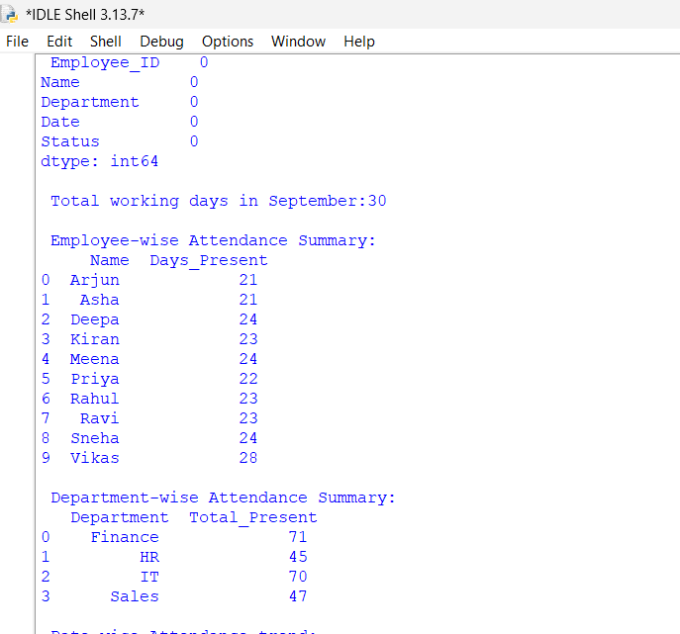

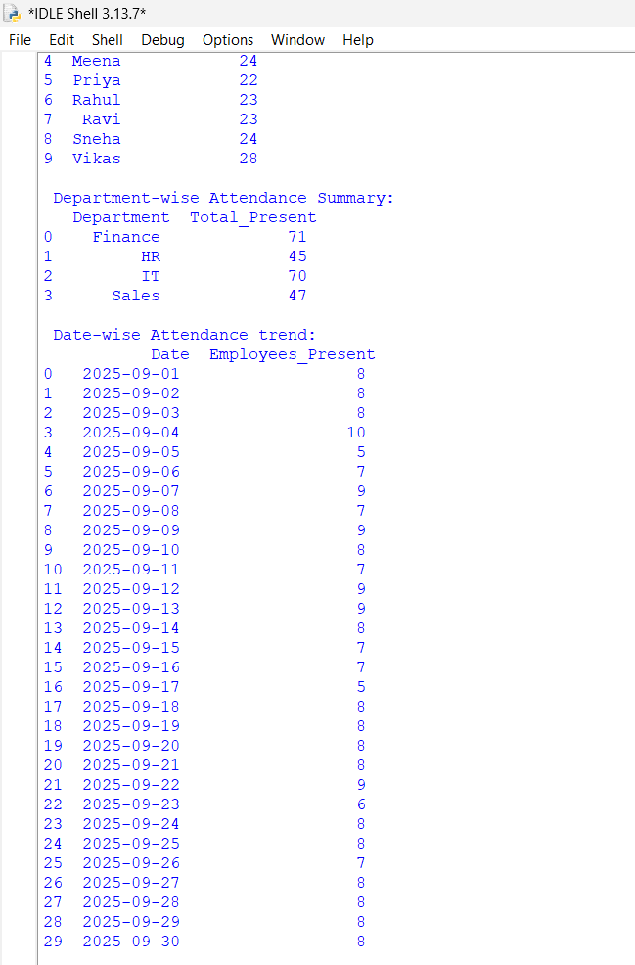
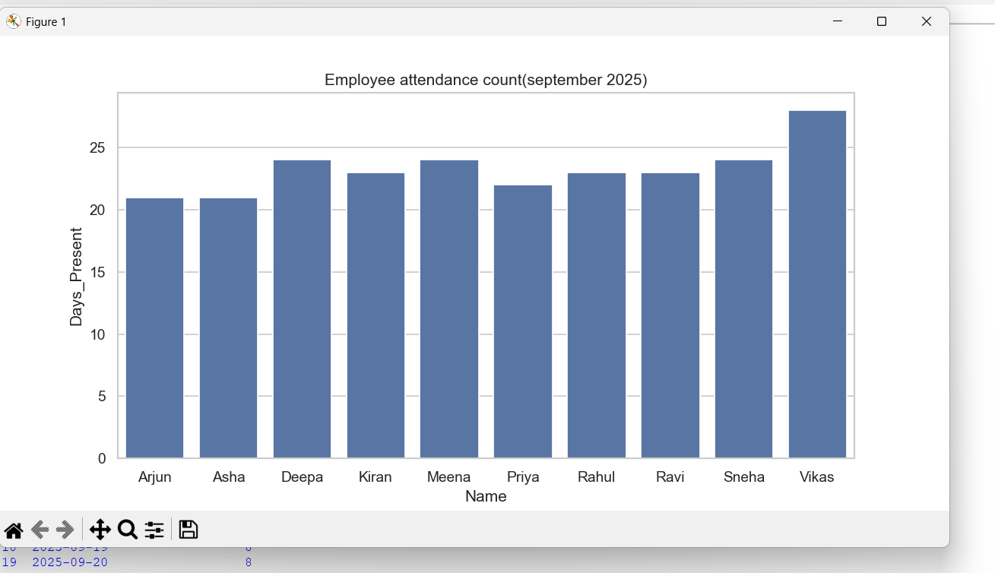

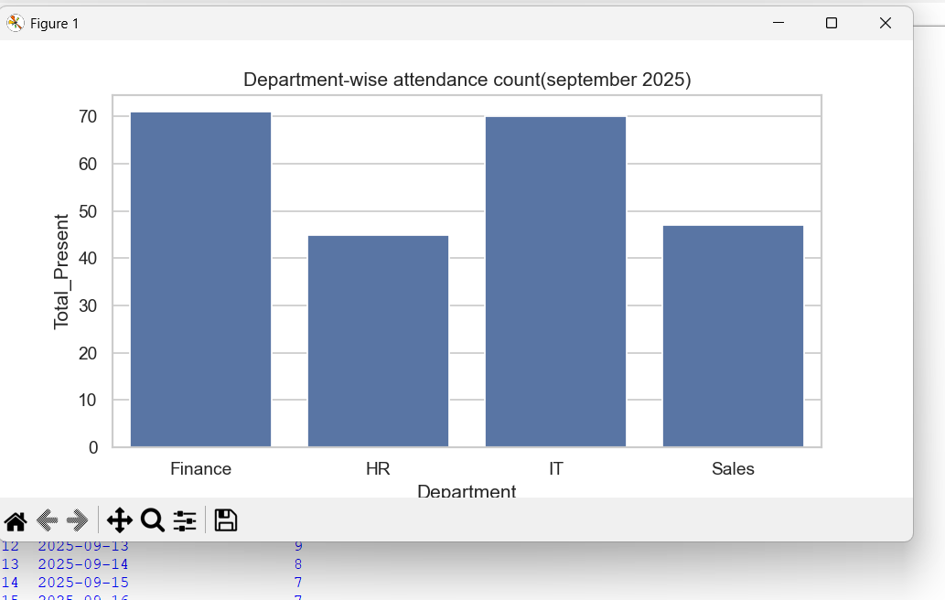

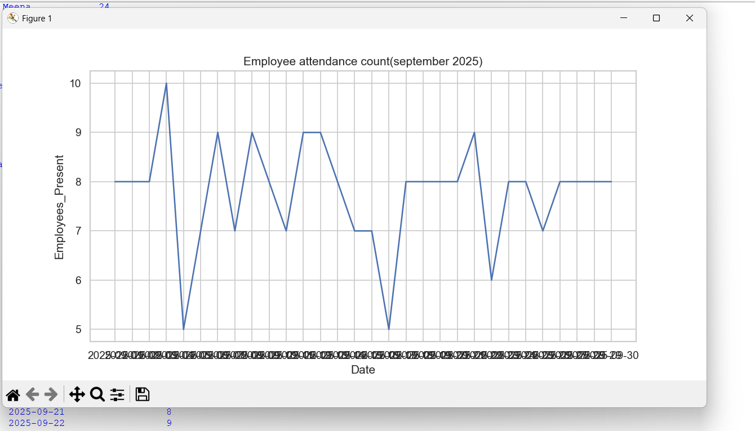

KEY INSIGHTS:
- Most Employees attended above 80% of working days.
- Finance department has the highest attendance rate.
- HR department has the lowest attendance rate.
- Vikas has the highest attendance among all the employees.
- Attendance patterns show consistent employee participation.

